Lagged cross-correlation: GBPUSD and EURGBP
Method 12 / daily log returns / K_max=10 / Alpari D1 full available history

Study setup
Logical pair: GBPUSD , EURGBP
Broker symbols: GBPUSD_i , EURGBP_i
Snapshot: 2026-11-03_majors_alpari_D1
Timeframe: D1
Matched return window: 1999-01-06 to 2026-11-02 (UTC bar dates)
Matched return count n: 7199
Dropped unfinished last bar dated 2026-11-03 UTC after a tick-volume check against the prior complete day.
Lag definition: rho_X->Y(k) = Corr(x_t, y_{t+k}) on matched D1 bars
K_max = 10; headline lag k = 1 (both directions)
Complete matched rows (Excel): GBPUSD-EURGBP_Lagged_D1.xlsx
Complete matched rows (HTML table): GBPUSD-EURGBP_Lagged_D1_data.html

Method carried forward
Lagged cross-correlation measures Pearson correlation between matched daily log returns of close, ln(close_t / close_t-1), after shifting one series forward by k bars on the matched panel. Quotes are not inverted. rho_{X->Y}(k) = Corr(x_t, y_{t+k}) with n_k = n - k. K_max = 10 is fixed before estimation. The headline is the pre-specified lag k = 1 in both directions. k = 0 is the same-bar side check. The lag inside 1..10 with the largest absolute rho is stored as a descriptive column only; it is not a selected result. This is a linear screen, not proof of forecast edge, economic cause, or a trading signal.

Results (headline k=1)
rho_GBPUSD->EURGBP(1): -0.042373 (n=7198)
95% Fisher interval GBPUSD->EURGBP: [-0.065411, -0.019290]
rho_EURGBP->GBPUSD(1): -0.012040 (n=7198)
95% Fisher interval EURGBP->GBPUSD: [-0.035133, 0.011065]
Same-bar rho(k=0): -0.397845
Largest |rho| among k=1..10 (descriptive only, not selected): GBPUSD->EURGBP k=1 rho=-0.042373; EURGBP->GBPUSD k=8 rho=0.037655

CCF table
k | rho_GBPUSD_to_EURGBP | n_GBPUSD_to_EURGBP | rho_EURGBP_to_GBPUSD | n_EURGBP_to_GBPUSD
0 | -0.3978452 | 7199 | -0.3978452 | 7199
1 | -0.0423732 | 7198 | -0.01204013 | 7198
2 | 0.00518714 | 7197 | 0.02519622 | 7197
3 | 0.0122813 | 7196 | -0.00441412 | 7196
4 | -0.00480701 | 7195 | 0.01853174 | 7195
5 | 0.03586711 | 7194 | 0.02855251 | 7194
6 | -0.02328261 | 7193 | 0.01186248 | 7193
7 | -0.00738327 | 7192 | 0.00108844 | 7192
8 | -0.00244643 | 7191 | 0.03765471 | 7191
9 | -0.02305651 | 7190 | 0.01568387 | 7190
10 | 0.00032346 | 7189 | 0.02048482 | 7189

Conclusion
At the pre-specified lag k=1 for GBPUSD and EURGBP, rho_{GBPUSD->EURGBP}(1) = -0.0424 (n=7198) and rho_{EURGBP->GBPUSD}(1) = -0.0120 (n=7198). Same-bar rho(k=0) = -0.3978. Largest |rho| among k=1..10 is descriptive only: GBPUSD->EURGBP at k=1 (-0.0424); EURGBP->GBPUSD at k=8 (0.0377). This is a linear screen, not forecast proof or a trading signal.

Charts
Daily closes

Daily log returns

CCF both directions k=0..10
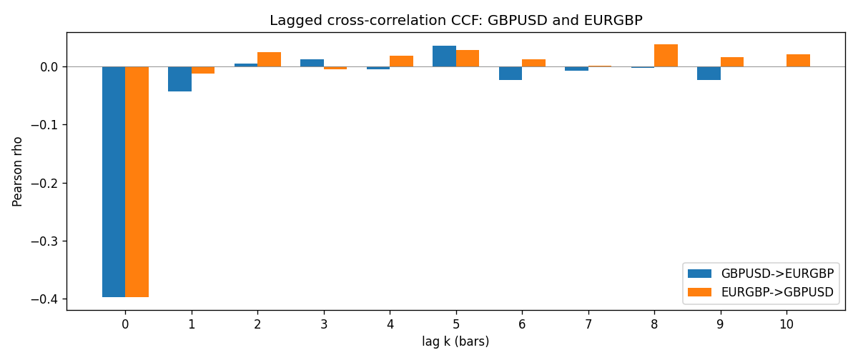

Data report
Every matched row is stored in the sibling Excel workbook named GBPUSD-EURGBP_Lagged_D1.xlsx (sheet matched_rows). The CCF sheet holds rho(k) for k=0..10. Embedding all rows as a Word table is impractical; the Word file holds column summaries and the first and last 15 rows.
Columns: time, GBPUSD_open, EURGBP_open, GBPUSD_high, EURGBP_high, GBPUSD_low, EURGBP_low, GBPUSD_close, EURGBP_close, GBPUSD_tick_volume, EURGBP_tick_volume, GBPUSD_spread, EURGBP_spread, GBPUSD_real_volume, EURGBP_real_volume, GBPUSD_log_return, EURGBP_log_return
Column summaries (matched calculation rows)
column | count | mean | std | min | 25% | 50% | 75% | max
GBPUSD_open | 7199 | 1.5160931 | 0.21831499 | 1.06854 | 1.324955 | 1.5114 | 1.63186 | 2.1066
EURGBP_open | 7199 | 0.78665041 | 0.09676322 | 0.5734 | 0.6873 | 0.83367 | 0.865175 | 0.9769
GBPUSD_high | 7199 | 1.5223838 | 0.21887686 | 1.08366 | 1.32978 | 1.5181 | 1.6384 | 2.1161
EURGBP_high | 7199 | 0.78972718 | 0.09713886 | 0.5789 | 0.68935 | 0.83657 | 0.86804 | 0.9799
GBPUSD_low | 7199 | 1.5097628 | 0.21753729 | 1.03518 | 1.3194 | 1.50323 | 1.62442 | 2.0983
EURGBP_low | 7199 | 0.78395066 | 0.09658082 | 0.5682 | 0.6853 | 0.83147 | 0.862765 | 0.9661
GBPUSD_close | 7199 | 1.5161471 | 0.21826306 | 1.06879 | 1.325055 | 1.51122 | 1.63216 | 2.1065
EURGBP_close | 7199 | 0.78669405 | 0.09676312 | 0.5735 | 0.6875 | 0.8337 | 0.86528 | 0.977
GBPUSD_tick_volume | 7199 | 94850.986 | 153561.38 | 62 | 9998.5 | 52911 | 91818.5 | 1273370
EURGBP_tick_volume | 7199 | 86949.029 | 145390.09 | 154 | 6517.5 | 44265 | 81326 | 1424684
GBPUSD_spread | 7199 | 26.96055 | 19.19062 | 0 | 11 | 20 | 50 | 50
EURGBP_spread | 7199 | 21.393666 | 19.14328 | 0 | 4 | 13 | 50 | 50
GBPUSD_real_volume | 7199 | 3.5570778e+09 | 8.4449923e+10 | 0 | 0 | 0 | 0 | 2.4038164e+12
EURGBP_real_volume | 7199 | 2.7805214e+10 | 1.3507095e+11 | 0 | 0 | 0 | 0 | 3.5726265e+12
GBPUSD_log_return | 7199 | -3.133e-05 | 0.00564236 | -0.08388241 | -0.00313644 | 2.978e-05 | 0.00317207 | 0.03112653
EURGBP_log_return | 7199 | 2.179e-05 | 0.00487166 | -0.03067367 | -0.0026225 | -0.00010035 | 0.00256076 | 0.06075387
First 15 matched rows (selected columns)
time | GBPUSD_close | EURGBP_close | GBPUSD_log_return | EURGBP_log_return
1999-01-06 | 1.6537 | 0.7019 | -0.00060452184 | -0.013303338
1999-01-07 | 1.6502 | 0.7097 | -0.002118709 | 0.011051402
1999-01-08 | 1.6405 | 0.7062 | -0.0058954193 | -0.004943862
1999-01-11 | 1.6312 | 0.7053 | -0.0056851331 | -0.0012752393
1999-01-12 | 1.6349 | 0.7077 | 0.0022657001 | 0.0033970309
1999-01-13 | 1.6499 | 0.708 | 0.0091330396 | 0.00042381861
1999-01-14 | 1.6531 | 0.7066 | 0.0019376331 | -0.0019793588
1999-01-15 | 1.6502 | 0.7012 | -0.0017558204 | -0.0076715819
1999-01-18 | 1.6522 | 0.7017 | 0.0012112405 | 0.00071280921
1999-01-19 | 1.6553 | 0.7007 | 0.0018745281 | -0.0014261269
1999-01-20 | 1.6472 | 0.7021 | -0.0049053846 | 0.0019960086
1999-01-21 | 1.6524 | 0.7016 | 0.0031518998 | -0.00071240297
1999-01-22 | 1.6565 | 0.7004 | 0.0024781662 | -0.0017118406
1999-01-25 | 1.6585 | 0.6966 | 0.0012066366 | -0.0054402425
1999-01-26 | 1.6597 | 0.6962 | 0.00072328374 | -0.00057438255
Last 15 matched rows (selected columns)
time | GBPUSD_close | EURGBP_close | GBPUSD_log_return | EURGBP_log_return
2026-10-13 | 1.32534 | 0.84458 | 0.0036434319 | 0.00020130374
2026-10-14 | 1.31884 | 0.84553 | -0.0049164679 | 0.0011241873
2026-10-15 | 1.32757 | 0.84479 | 0.0065976411 | -0.00087557391
2026-10-16 | 1.33257 | 0.84307 | 0.0037592051 | -0.0020380844
2026-10-19 | 1.33024 | 0.84259 | -0.0017500314 | -0.00056950988
2026-10-20 | 1.3377 | 0.83957 | 0.0055923442 | -0.0035906254
2026-10-21 | 1.33937 | 0.83839 | 0.0012476328 | -0.00140647
2026-10-22 | 1.33967 | 0.83682 | 0.00022396082 | -0.0018743924
2026-10-23 | 1.33684 | 0.83751 | -0.0021146949 | 0.00082421033
2026-10-26 | 1.33359 | 0.83762 | -0.0024340661 | 0.00013133309
2026-10-27 | 1.33044 | 0.83595 | -0.0023648393 | -0.0019957343
2026-10-28 | 1.33254 | 0.83651 | 0.0015771808 | 0.00066967224
2026-10-29 | 1.33733 | 0.83553 | 0.0035881935 | -0.0011722209
2026-10-30 | 1.33913 | 0.83351 | 0.0013450605 | -0.0024205543
2026-11-02 | 1.3406 | 0.83426 | 0.0010971256 | 0.00089940465

